To connect to the wifiModule, follow these simple steps:
- Locate the module on your networks (module must be powered on)
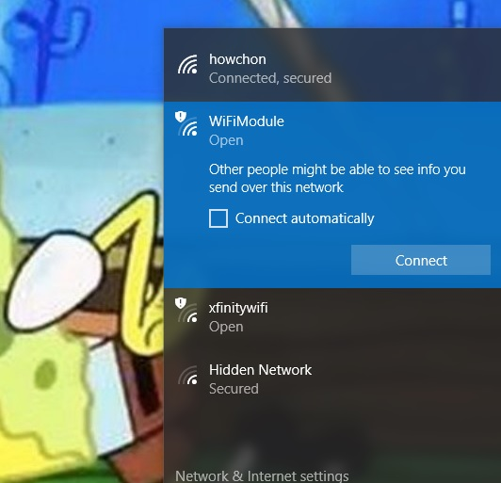
- Connect to the wifiModule (you may need to disconnect from your network first)
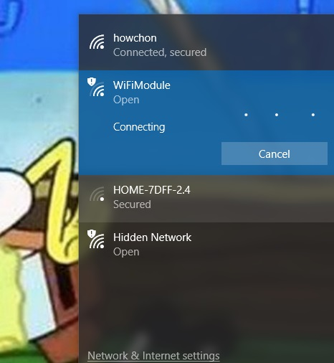
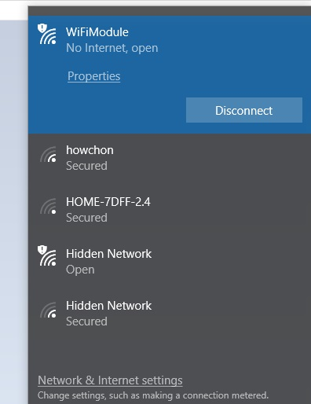
- Open your browser and type “192.168.4.1” in the address bar.
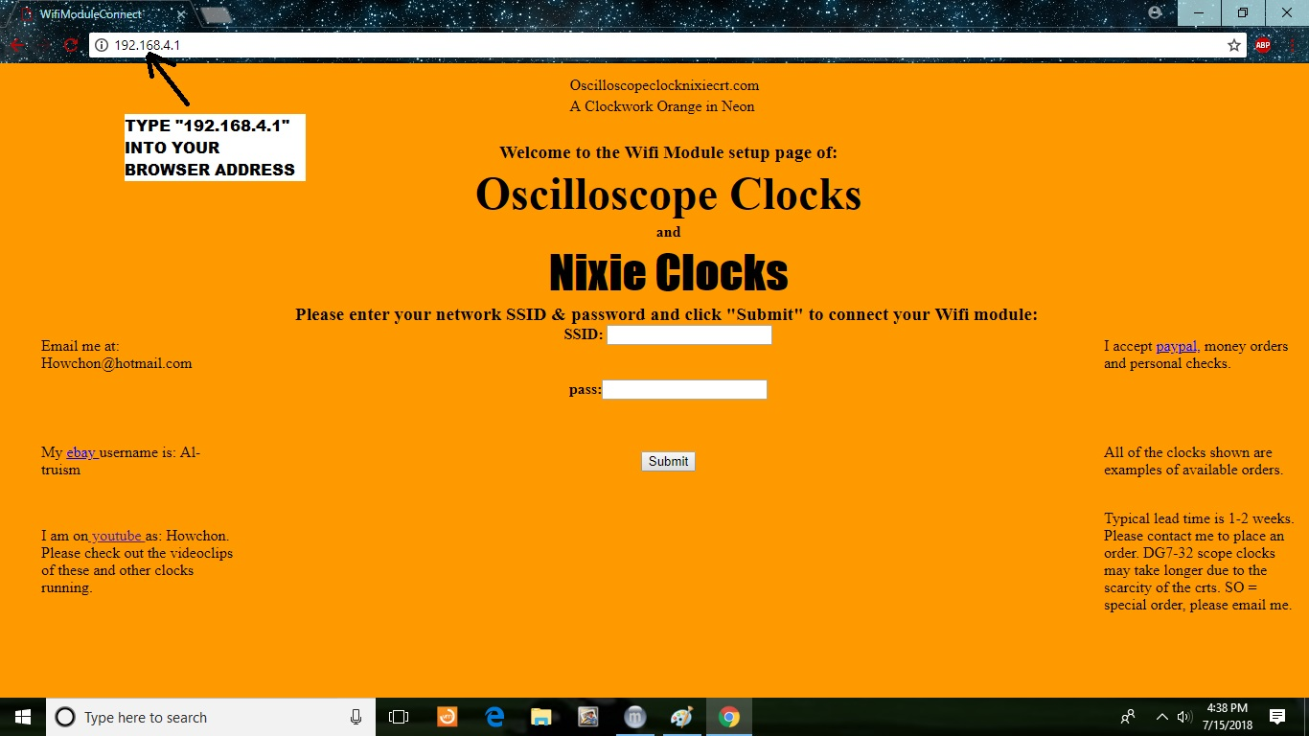
- The wifiModule setup page should appear, and then type in your network name & network password.
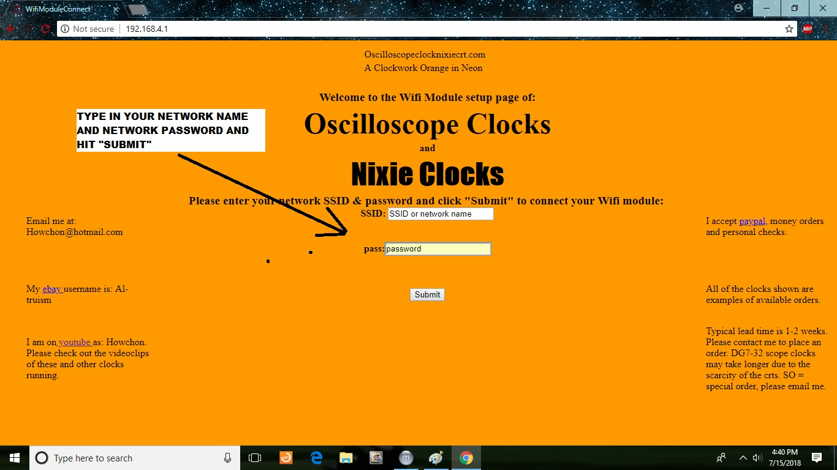
- Click “Submit” and the confirmation page appears. Your module is now connected to the network.
